Name:  Class: | ____________________________________  ________________ |  | Date:_________
 | Year 11 Foundations Mathematics  / 30  5 %  Test 1 2018  Topic – Numbers and Place Value
Total Time: | 45 minutes
Weighting: | 5%
Equipment: | To be provided by the student: Pen, pencil, ruler,1 double sided A4 page of notes, scientific calculator

- [3 marks]
Write down the purpose of the whole number in the various examples that follow. For each whole number select one purpose of the number from:
- quantity
- order
- label

- Amy received $25 for babysitting a neighbour’s child.
- Sidnei Moraes wears the number 16 shirt for Perth Glory Football Club.
- Usain Bolt came 1st in a running race in August last year in Brazil.
- [1, 1, 1, 1, 2, 1 = 7 marks]
Complete the place value chart for the following numbers.
- 49
- Seven hundred and six
- Five thousand three hundred and ninety four
- 80 794
- Two hundred thousand and sixteen
- 41 008 045
Millions |  |  | Thousands |  |  | Ones
Hundreds | Tens | Ones | Hundreds | Tens | Ones | Hundreds | Tens | Ones

- [1, 1, 1, 1, 1 =5 marks]
Write the following numbers in words.
- 42
- 607
- 5 009
- 100 210
- 190 300 350
- [1, 1, 1 = 3 marks]
Place the following numbers in order from smallest to largest (ascending order).
- 1 032, 132, 123, 1 023

- 97 006, 963, 97 236, 9 263

- 2 140 630, 2 410 630, 2 014 630

- [1 mark]
Harry was counting the boxes of potato chips in the store room of the supermarket that he works at. The packets of chips come in boxes of 20. Complete the sequence Harry was counting forward with:

______ , 40, 60, 80, ______, ______, ______.

- [5 marks]
Complete the following table.
Money as a number | Money in Words | Ranking  1 – smallest, 4 - largest
 | One thousand, two hundred and nine dollars and forty cents
$4.75
 | Three hundred and eighty million, seven hundred and fifty two thousand dollars and twenty one cents
$211 052

- [2 marks]
Two of the following statements contain incorrect information. Circle the letter next to the incorrect statements.
- The average weight of a family sized block of chocolate is 220g.
- The oldest living tree is a conifer in Sweden. It is estimated to be 955 000 years old.
- The population of Perth in 2014 was 8 173.
- The cost of a dozen eggs is $3.00.

- 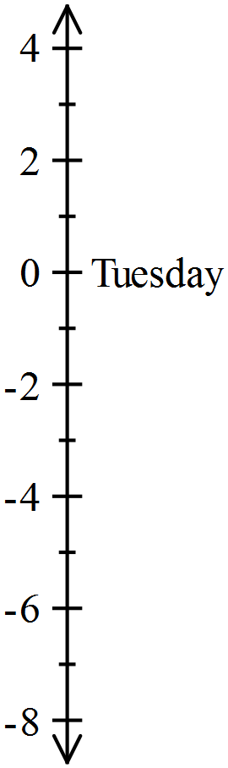 [1, 1, 1, 1 = 4 marks]
The temperatures for five days in New York are given in the table below.
Day | Temperature
Monday | -4°C
Tuesday | 0°C
Wednesday | 2°C
Thursday | -3°C
Friday | -7°C

- Place the temperatures on the vertical scale provided.
Tuesday is done for you.

- What is the lowest temperature?
- What is the highest temperature?
- How many degrees did the temperature drop between Thursday and Friday?

END OF ASSESSMENT

